Shaquire Dean

Biological Molecules/Macromolecules/Organic Compounds/Biomolecules
Biomolecule | Elements | Structure | Monomer  (Building Blocks) | Polymer | Bond (Covalent) | Example | Function
Carbohydrates | C₁ H₂ O₁ | 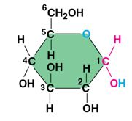 | Monosaccharides | polysaccharide | glycosidic bond | Glucose | Source of Energy
Lipids | CHO | 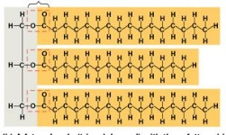 | Glycerol and Fatty Acids | Glycerides, Triglycerides | Ester bond | Fats and Oils | Store and Transfer Chemical energy
Proteins | CHON(S) | 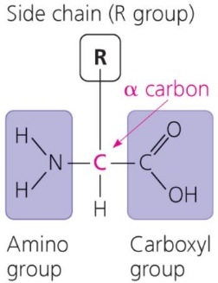  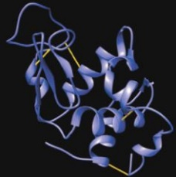 | Amino Acids | Polypeptide | Peptide bond | Myosins | Building block of the Body.
Nucleic acid | CHON-P | 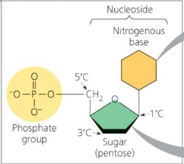 | Nucleotide | Polynucleotide | phosphodiester bond | DNA and RNA | Store and transmit hereditary information
Disaccharide:
- Maltose (Malt sugar)- Glucose + Glucose
- Lactose (Milk sugar)- Glucose + Galactose
- Sucrose (table sugar)- Glucose + Fructose
Prefixes/Suffixes:
- Gly- Glycerol
- Glu- Glucose
- –ose- Sucrose
- Sacchar-Saccharides
Protein Structural Levels:
- Primary- Amino Acid Sequence
- Secondary- Local interactions exists between various stretches of the polypeptide.
- Tertiary- 3-dimensions fold due to the interactions between the R-groups.
- Quaternary- Orientation as well as arrangement of the subunits within the multi-subunits proteins.

